Frequently asked Q&A about applications to Chemical Engineering Graduate Program at Missouri S&T

# What is the application process and priority application deadline?

Although there are more than 40 graduate programs at Missouri S&T, the campus has been using only one application platform for all, nicknamed Slate: <https://connect.mst.edu/apply>/ . A new applicant needs to create an account first before submitting application materials. The application materials include Cover letter (Statement of Purpose), Transcripts, three Letters of recommendation, and Test scores. If all the needed documents were not submitted, the application will be kept in the “Awaiting Materials” bin. If all application materials were submitted but the application fee has not been paid, the application is kept in the “Awaiting Payment” bin. The department cannot process these cases until they are forwarded out of the two bins.

Although we do consider graduate applications all year long because professors may have funded projects starting in different months, we recommend submitting complete applications before the following deadlines to increase your opportunities to be admitted and funded:

Fall semester –June 15 for international students and July 15 for US students

Spring semester –November 15 for international students and December 15 for US students.

# What is the standard admission criterion?

Graduate admissions are determined by the graduate committee, of which the chair is the graduate coordinator, and the faculty together. In general, the graduate admission criterion has four major components: academic credentials (GPA, school, etc.), letters of recommendation, and English proficiency test (GRE optional). Understandably, the academic credentials, including the BS major and university background, tend to be the most important factor. Plus, there is a **minimum requirement of cumulative BS GPA at/above 3.0/4.0**. The minimum of English proficiency is set by the university and is explained in detail later in this document. Although the department and the university are willing to be more flexible with the admission criterion for non-thesis MS and self-supported students, we do want and need to ensure proper preparedness for future academic success in our graduate program by examining these four components.

**Prior MS degree is not required for PhD applications.** In fact, BS degree holders with good credentials are encouraged to apply directly to PhD program without going through MS because professors with funded projects and financial support to offer typically prefer PhD students much more than MS students.

# Can the chemical engineering graduate program waive the application fee for an applicant that was affected by the pandemic or other hardships?

The application fee is collected NOT by the department but by the university which is above and beyond us. As a result, the department has NO decision or control over the application fee. To our knowledge, the application fee CANNOT be waived but could be paid by a third party such as a professor who is recruiting a particular student. To find such a sponsor, please refer to items 2 and 3.

# The possibility of getting financial support via Graduate Research/Teaching Assistantship (GRA or GTA)?

For PhD students, we very seldom admit one without funding, meaning that we typically admit those who have been selected for Graduate Research Assistantship by professors having funded projects or Graduate Teaching Assistantship by the department. The total number of admitted new PhD students varies from semester to semester and year to year, but recently has been about 6-7 in Fall and 5-6 in Spring. For MS students, the majority, in particular non-thesis MS students, are self-supported because research investigators (professors) all have strong or exclusive preference for PhD students. The very few funded MS positions are either directly agreed/recruited by professors or by the department to fulfill special needs (e.g., lab TA). However, it is possible and not uncommon for a non-funded graduate student to become funded during their study after successfully talking to a research investigator (professor).

International students are required by the US government to show sufficient support for securing their student (F1) Visa. According to the Office of International Affairs at Missouri S&T, the needed amount, the so-called Student I-20 Expenses, has been $45,967/year in recent years. This amount can be covered by the funding support of a GRA or GTA, or by the student’s own financial statement.

# Do I need to contact a potential advisor before applying?

It might help because each semester we receive many qualified applications, more than we can admit. When an applicant is recruited or picked up (via interview or examining application materials) by a professor who has funded project(s) to sponsor graduate student(s), such a mutual commitment is typically honored and processed immediately by the department unless the applicant’s credentials have severe deficiencies. For the rest applicants, they are screened and then ranked into different groups based on our admission criterion stated above. They will then be circulated among the graduate committee and the faculty for admission decisions.

# Can I join the Chemical Engineering graduate program from a non-ChE BS major?

Although most of our graduate students are from ChE BS programs, we do admit those from a non-ChE background. For non-ChE students pursuing ChE PhD degree, they will be advised to go through certain “bridge” courses before taking the required graduate courses. These bridge and required courses can be used to earn a non-thesis MS degree alongside the PhD study. For non-ChE students pursuing ChE MS degree, similar bridge courses need to

be completed first before taking the required graduate courses. These bridge and required courses can be used to earn a graduate certificate or two alongside their MS degree.

# What is the minimum TOEFL score requirement of the program?

English requirement is mandatory and regulated by the university, not by the department. It usually requires TOEFL ≥ 79, IELTS ≥ 6.5, Duolingo ≥ 105, or PTE≥ 53. Very occasionally, a student may be recruited and then admitted without meeting the minimum English requirement. The student will be asked to take one of the English proficiency tests before or after arrival without certain time. Please note that Missouri S&T no longer has Intensive English Program and that the following countries are exempt from providing English Proficiency test scores.

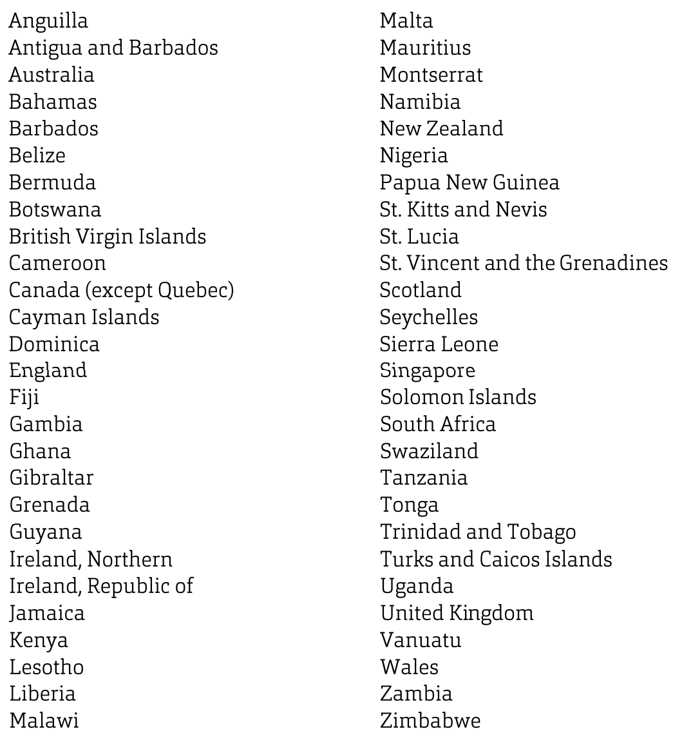

# What is the minimum GRE requirement of the program?

The department has recently made a decision to make GRE optional, meaning that GRE is no longer required for graduate applications but a good GRE score may be a tie breaker to favor one applicant over other competitors. For your reference, the previous GRE requirement is (V+Q) ≥ 300 as a minimum.

# Can I upload the unofficial Academic Transcript, GRE and TOEFL score for review purposes?

The electronic application website at <http://connect.mst.edu/apply> accepts photocopies of transcripts, diplomas, tests, letters of recommendation, etc. The university will review these documents first before forwarding the applications to the department for admission consideration. During the process, the applications will be placed in different bins such as “Awaiting Materials”, “Awaiting Payment”, “Awaiting Submission”, etc. By checking your application status in different bins, you could find out if your documents are acceptable for review purpose. You may still need to provide official transcript(s) and diploma(s) to the Office of Graduate Studies even after admission for additional considerations such as course transferability, graduate degree equivalency, etc.

# What if I got admitted but must arrive late after a semester has started?

Students may arrive up to ~30 days before the program start date which is indicated on I-20 in the case of international students. Late arrival after a semester starts is acceptable but the student’s advisor needs to fill out and submit to the Office of International Affairs a “Late Arrival Request” form where the latest arrival date allowed is specified. The Office will then update and release the updated I-20 to the student. Late arrival students within two weeks after a semester starts can directly register/add courses electronically using JoeSS but need to use a Late Registration paper form from the Registrar if it is later than two weeks. If it is way too late, then it may be advisable to defer to the next semester upon approval of the sponsoring advisor and/or the department.

# Can courses from a previous graduate degree study be transferred?

A graduate course from another university could be transferred if it was taken for graduate credit, a B or better grade, and not used toward another degree. While the university’s coursework requirements specify the number of credit hours, the ChBE department’s coursework requirements, established by the faculty, specify what courses qualify for these credit hour requirements. The graduate core courses required for ALL graduate students are ChE 5100 (Intermediate Transport Phenomena), ChE 5110 (Intermediate Chemical Reactor Design), and ChE 5220 (Intermediate Engineering Thermodynamics). Non-thesis MS students should also take ChE 5150 (Intermediate Process Computing). PhD students are further required to take ChE 6100 (Advanced Chemical Engineering Thermodynamics) and ChE 6110 (Advanced Transport Phenomena). It is possible for students to be waived out of one or more required graduate core courses, but such decisions are made by the graduate committee and course instructors in the department based on the students’ transcripts and related course documents (syllabus, list of topics, etc.)